Coversheet |  | 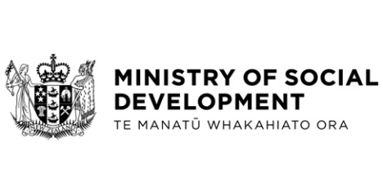

Report of the Independent Expert on the enjoyment of all human rights by older persons: New Zealand Response

Hon Ginny Andersen, Minister for Seniors
These documents have been proactively released.
23 November 2022, Cabinet Social Wellbeing Committee Minute SWC-22-MIN-0217, Cabinet Office.
28 November 2022, Cabinet paper - Report of the Independent Expert on the enjoyment of all human rights by older persons: New Zealand Response, including:

- Appendix 1 - Report of the Independent Expert on the enjoyment of all human rights by older persons on her mission to New Zealand: comments by the State org/doc/UNDOC/GEN/G23/012/01/PDF/G2301201.pdf?OpenElement
- Appendix 2 – Report of the Independent Expert on the enjoyment of all human rights by older persons on her visit to New Zealand (published here: https://digitallibrary.un.org/record/3875126)
- Appendix 3 – Statement in response to the Independent Expert’s presentation at the United Nations Human Rights Council (www.mfat.govt.nz/en/media-and-resources/45th-session-human-rights-council-report-on-the-enjoyment-of-all-human-rights-by-older-persons-country-visit/).

These papers represent a formal statement of Government positions on the human rights of older persons in New Zealand, responding to recommendations made by the former Independent Expert on the enjoyment of all human rights by older persons, on her visit to New Zealand from 2 to 12 March 2020.

© Crown Copyright, Creative Commons Attribution 4.0 International (CC BY 4.0)
Search Tags: Independent Expert, older persons, older people, human rights, United Nations, Office for Seniors

